12.54: Equation 12.14 in the text will give us the planet’s mass:
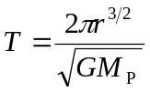
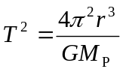
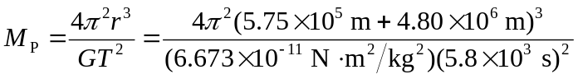
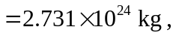or about half earth’s mass.
Now we can find the astronaut’s weight on the surface (The landing on the north pole removes any need to account for centripetal acceleration):
